COURSE: CSA1715-Artificial Intelligence | Name: EKALAIVAN L
DATE: 02.08.2026 | Reg.no: 192524450

EXPERIMENT 9: Write a python program to implement Travelling Salesman Problem
Aim
To find the shortest route that visits every city exactly once and returns to the starting city.

Algorithm

Step 1: Start the program.
Step 2: Store the distance between each pair of cities in a matrix.
Step 3: Fix the first city as the starting city.
Step 4: Generate all possible orders of the remaining cities.
Step 5: Calculate the total travel cost of every route.
Step 6: Select the route having the minimum cost.
Step 7: Display the best route and minimum cost, then stop.

Program
from itertools import permutations

# Distance matrix for four cities
distance = [
[0, 10, 15, 20],
[10, 0, 35, 25],
[15, 35, 0, 30],
[20, 25, 30, 0]
]

n = len(distance)
start = 0
best_cost = float("inf")
best_path = None

for order in permutations(range(1, n)):
path = (start,) + order + (start,)
cost = sum(distance[path[i]][path[i + 1]] for i in range(n))

if cost < best_cost:
best_cost = cost
best_path = path

print("Best Path:", " -> ".join(map(str, best_path)))
print("Minimum Cost:", best_cost)

Output
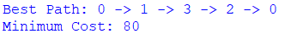
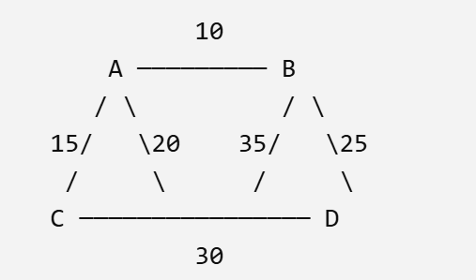
Result
Thus, the Travelling Salesman Problem was implemented successfully, and the minimum-cost route was obtained.

EXPERIMENT 10: Write a python program to implement A* algorithm

Aim
To find the shortest path between a start node and a goal node using the A* Search Algorithm.

Algorithm

Step 1: Start the program and create a weighted graph.
Step 2: Assign a heuristic value to every node.
Step 3: Insert the start node into a priority queue.
Step 4: Remove the node having the minimum f(n) = g(n) + h(n).
Step 5: Generate its unvisited neighbouring nodes.
Step 6: Repeat until the goal node is selected.
Step 7: Display the shortest path and its cost, then stop.

Program
import heapq

graph = {
"A": {"B": 1, "C": 4},
"B": {"D": 5, "E": 2},
"C": {"E": 1},
"D": {"G": 3},
"E": {"G": 3},
"G": {}
}

heuristic = {
"A": 6,
"B": 5,
"C": 4,
"D": 3,
"E": 3,
"G": 0
}

def astar(start, goal):
queue = [(heuristic[start], 0, start, [start])]
visited = set()

while queue:
f, cost, node, path = heapq.heappop(queue)

if node == goal:
return path, cost

if node in visited:
continue

visited.add(node)

for nxt, edge_cost in graph[node].items():
if nxt not in visited:
new_cost = cost + edge_cost

heapq.heappush(
queue,
(
new_cost + heuristic[nxt],
new_cost,
nxt,
path + [nxt]
)
)

return None, 0

# Calling the A* function
path, cost = astar("A", "G")

if path:
print("Shortest Path:", " -> ".join(path))
print("Total Cost:", cost)
else:
print("No path found.")
path, cost = astar("A", "G")
print("Shortest Path:", " -> ".join(path))
print("Path Cost:", cost)

Output
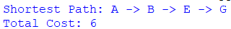

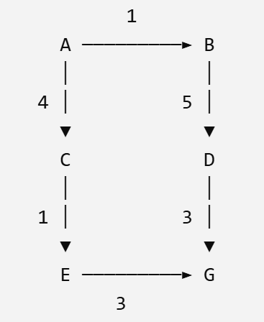
Result
Thus, the shortest path was successfully found using the A* Search Algorithm.

EXPERIMENT 11: Write a python program for Map Coloring to implement CSP
Aim

To colour a map using Constraint Satisfaction and Backtracking so that adjacent regions have different colours.

Algorithm

Step 1: Start the program and define the regions and their neighbours.
Step 2: Create a set of available colours.
Step 3: Select one unassigned region.
Step 4: Assign a colour that does not violate neighbour constraints.
Step 5: Move to the next region when the assignment is valid.
Step 6: Backtrack when no colour is valid for a region.
Step 7: Display the final colour assignment and stop.

Program
regions = ["WA", "NT", "SA", "Q", "NSW", "V", "T"]
colors = ["Red", "Green", "Blue"]

neighbours = {
"WA": ["NT", "SA"],
"NT": ["WA", "SA", "Q"],
"SA": ["WA", "NT", "Q", "NSW", "V"],
"Q": ["NT", "SA", "NSW"],
"NSW": ["Q", "SA", "V"],
"V": ["SA", "NSW"],
"T": []
}

assignment = {}

def is_safe(region, color):
return all(assignment.get(n) != color
for n in neighbours[region])

def solve(index=0):
if index == len(regions):
return True

region = regions[index]
for color in colors:
if is_safe(region, color):
assignment[region] = color
if solve(index + 1):
return True
del assignment[region]
return False

if solve():
for region in regions:
print(region, "=", assignment[region])
else:
print("No valid coloring exists.")

Output
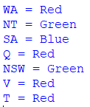

Result
Thus, the Map Coloring Problem was solved successfully using CSP and Backtracking.

EXPERIMENT 12: Write a Python Program for Tic-Tac-Toe Game
Aim
To develop a Python program to implement the Tic-Tac-Toe game for two players.
Algorithm
Step 1: Start the program.
Step 2: Create a 3×3 empty game board.
Step 3: Display the board to the players.
Step 4: Ask the current player to enter a position from 1 to 9.
Step 5: Place the player’s symbol in the selected position.
Step 6: Check whether the player has won the game.
Step 7: If no player wins, switch between Player X and Player O.
Step 8: Declare the game as a draw when all positions are filled.
Step 9: Stop the program.

Program
board = [" "] * 9

def display_board():
print()
print(board[0], "|", board[1], "|", board[2])
print("--+---+--")
print(board[3], "|", board[4], "|", board[5])
print("--+---+--")
print(board[6], "|", board[7], "|", board[8])
print()

def check_winner(player):
winning_positions = [
(0, 1, 2), (3, 4, 5), (6, 7, 8),
(0, 3, 6), (1, 4, 7), (2, 5, 8),
(0, 4, 8), (2, 4, 6)
]

for a, b, c in winning_positions:
if board[a] == board[b] == board[c] == player:
return True

return False

player = "X"

print("Tic-Tac-Toe Game")
print("Enter positions from 1 to 9")

for turn in range(9):
display_board()

while True:
position = int(input("Player " + player + ", enter position: ")) - 1

if 0 <= position <= 8 and board[position] == " ":
board[position] = player
break
else:
print("Invalid position. Try again.")

if check_winner(player):
display_board()
print("Player", player, "wins!")
break

if player == "X":
player = "O"
else:
player = "X"
else:
display_board()
print("The game is a draw.")

Output
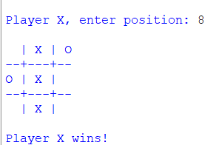

Result
Thus, the Tic-Tac-Toe game was successfully implemented using Python, and the winner or draw condition was displayed successfully.

EXPERIMENT 13: Write a python program to implement Minimax algorithm for gaming
Aim
To determine the best possible game value using the Minimax Algorithm.

Algorithm

Step 1: Start the program and store the terminal game scores.
Step 2: Begin at the root node as the maximizing player.
Step 3: Recursively evaluate the left and right child nodes.
Step 4: Choose the maximum value at maximizing levels.
Step 5: Choose the minimum value at minimizing levels.
Step 6: Continue until the root value is obtained.
Step 7: Display the optimal value and stop.

Program

MAX_DEPTH = int(input("Enter maximum depth: "))

leaf_count = 2 ** MAX_DEPTH
print("Enter", leaf_count, "leaf-node scores:")

scores = list(map(int, input().split()))

if len(scores) != leaf_count:
print("Error: You must enter exactly", leaf_count, "scores.")
else:
def minimax(depth, index, maximizing):
if depth == MAX_DEPTH:
return scores[index]

left = minimax(depth + 1, index * 2, not maximizing)
right = minimax(depth + 1, index * 2 + 1, not maximizing)

if maximizing:
return max(left, right)
else:
return min(left, right)

best_value = minimax(0, 0, True)

print("Optimal Value:", best_value)

Output

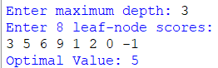

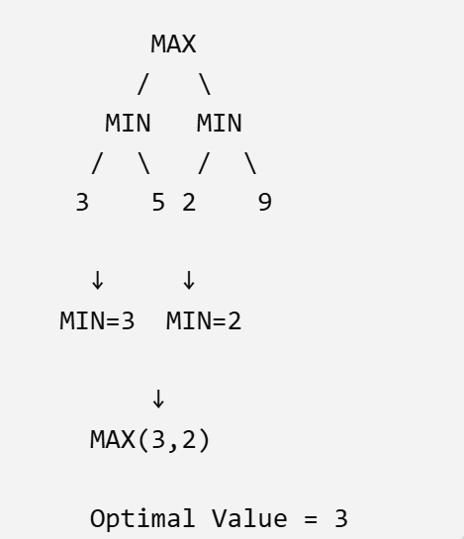
Result
Thus, the optimal game value was successfully obtained using the Minimax Algorithm.

EXPERIMENT 15: Write a python program to implement Alpha and Beta pruning algorithm for gaming
Aim
To find the optimal game value efficiently using Alpha-Beta Pruning.

Algorithm

Step 1: Start the program and store the terminal game scores.
Step 2: Initialize alpha as negative infinity and beta as positive infinity.
Step 3: Evaluate nodes using the Minimax rules.
Step 4: Update alpha at maximizing nodes.
Step 5: Update beta at minimizing nodes.
Step 6: Prune the remaining branch whenever beta is less than or equal to alpha.
Step 7: Display the optimal value and stop.

Program

# Alpha-Beta Pruning Algorithm

visited_leaves = 0

def alpha_beta(depth, index, maximizing, alpha, beta):
global visited_leaves

# Return the leaf-node value
if depth == max_depth:
visited_leaves += 1
return scores[index]

# Maximizing player's turn
if maximizing:
best_value = float("-inf")

for child_index in (index * 2, index * 2 + 1):
value = alpha_beta(
depth + 1,
child_index,
False,
alpha,
beta
)

best_value = max(best_value, value)
alpha = max(alpha, best_value)

# Beta cutoff
if beta <= alpha:
break

return best_value

# Minimizing player's turn
else:
best_value = float("inf")

for child_index in (index * 2, index * 2 + 1):
value = alpha_beta(
depth + 1,
child_index,
True,
alpha,
beta
)

best_value = min(best_value, value)
beta = min(beta, best_value)

# Alpha cutoff
if beta <= alpha:
break

return best_value

# Main program
max_depth = int(input("Enter the maximum depth of the game tree: "))

total_leaves = 2 ** max_depth

print("Enter", total_leaves, "leaf-node scores separated by spaces:")
scores = list(map(int, input().split()))

if len(scores) != total_leaves:
print("Error: You must enter exactly", total_leaves, "scores.")

else:
optimal_value = alpha_beta(
0,
0,
True,
float("-inf"),
float("inf")
)

pruned_leaves = total_leaves - visited_leaves

print("\nOptimal Value:", optimal_value)
print("Total Leaf Nodes:", total_leaves)
print("Visited Leaf Nodes:", visited_leaves)
print("Pruned Leaf Nodes:", pruned_leaves)

Output
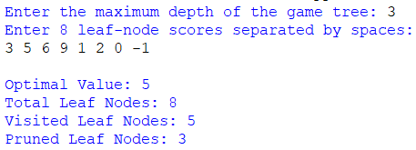

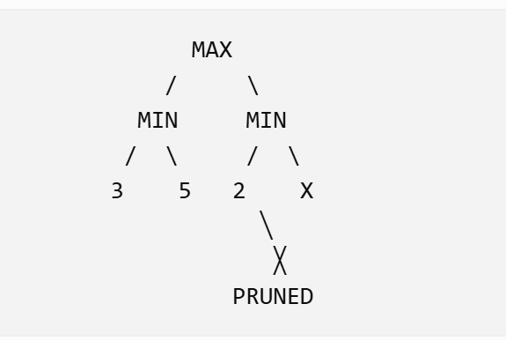

Result
Thus, the optimal game value was obtained successfully using Alpha-Beta Pruning with fewer node evaluations.

EXPERIMENT 16: Write a python program to implement Decision Tree

Aim
To classify student performance using the Decision Tree Classification Algorithm.

Algorithm

Step 1: Start the program and import the required library.
Step 2: Create the feature values and their class labels.
Step 3: Initialize the Decision Tree classifier.
Step 4: Train the model using the given dataset.
Step 5: Provide a new sample to the trained model.
Step 6: Predict its class and calculate training accuracy.
Step 7: Display the result and stop the program.

Program
# Simple Decision Tree Program

print("===== Decision Tree: Play Tennis Prediction =====")

outlook = input("Enter Outlook (Sunny/Overcast/Rain): ").lower()

if outlook == "overcast":
result = "Yes"

elif outlook == "sunny":
humidity = input("Enter Humidity (High/Normal): ").lower()

if humidity == "high":
result = "No"
elif humidity == "normal":
result = "Yes"
else:
result = "Invalid humidity value"

elif outlook == "rain":
wind = input("Enter Wind (Strong/Weak): ").lower()

if wind == "strong":
result = "No"
elif wind == "weak":
result = "Yes"
else:
result = "Invalid wind value"

else:
result = "Invalid outlook value"

print("\nDecision: Play Tennis =", result)

Output
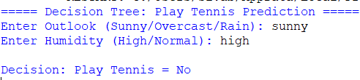
Result
Thus, the Decision Tree model was trained successfully and used to predict the given class.

